BIRMINGHAM-SOUTHERN COLLEGE
CAMPUS POLICE
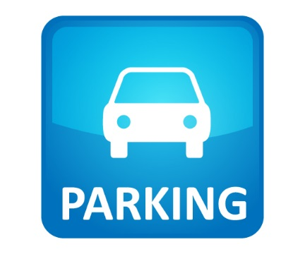
Parking Rules Birmingham-Southern College Campus

- All cars on campus must be registered and display the appropriate decal for the current academic year. To register a car on campus, all students must possess a valid and current driver’s license.
- The $80 parking decal charge will appear on your Student Account in the fall. Faculty and Staff decals have no charge.
- Parking decals must be permanently affixed to the lower left front windshield of the registered vehicles; old decals should be removed prior to applying the current year's decal; Campus Police can assist with removal and placement at the Front Gate.
- If a current decal is not displayed on the vehicle, a traffic citation for Expired or No Decal will be issued ($75).
- Vehicles are not allowed to park in disabled parking spaces without the proper tag or parking decal. These spaces are denoted with blue striping or blue curb paint.
- Be aware of curb cuts and ramps, and do not block these areas. The ramps and curb cuts provide access for people with disabilities.
- Students may park only in white bracketed parking spaces or spaces with white curbs. Students also may park in bracketed spaces with unpainted curbs.
- Green curbs are reserved for faculty and staff. Students may park in green curb spaces after 5:00 p.m. Monday through Friday. Vehicles must be moved by 7:00 a.m. Monday through Friday.
- Red curbs are reserved parking and denote “no parking anytime” spaces.
- Students should not park in the spaces by the Admission Welcome Center where signs are posted.
- No students, faculty or staff may park in the United Methodist Conference Center parking lot except when on official business or as directed by Campus Police.
- Parking in loading zones is limited to ten (10) minutes for loading and unloading purposes only.
- At no time will parking be permitted in tow away zones designated by either a striped area or chain.
- No parking in areas blocked by traffic pylons or cones.
- The speed limit on campus is 20 miles per hour except in designated areas and in parking lots. The speed limit in parking lots is 5 miles per hour.
- Students are responsible for ensuring guests drive and park properly while on campus. Fines issued to guests will be the responsibility of the student they are visiting.
- If you want to file an appeal of a parking or traffic ticket, please go to the following link: https://www.bsc.edu/campus/police/ticket-appeal.html

